Habit Tracker
From app concept to open source program

Development Phase



Further training project of
https://www.iu-akademie.de

Project by
Björn Leue, *25.11.1985
iu akademie e-mail: bjoern.leue@iu-academy.org
personal e-mail: webmaster@wildsite.de

Last editing: 21.02.23

Contentlist

Development Phase - Lookover 1

Files 2

Folders 3

Starting app by commandline / terminal 4

Using app by webinterface 5

The Webinterface 6

To-do's 7

Development Phase – Lookover

I started to write code to control the app, so i created the HabitTracker.py file.
In this file the app get all the given attributes and handle it.
When i give the attributes
action=UserLogin username=testuser password=password
it start's the function login_user, given in actions.py.
In that function, i start a function for searching in the SQLite database and give back some data, if there are the given user and the given password.
The possible attributes for all actions you'll find in the README.md.

I developed it for Windows and Linux systems, but in Linux you have to install some php packages and you have to do some settings in apache2 server.

For running the webpage with XAMPP server you have to take a copy of the program for example to
C:\\xampp\htdocs\HabitTracker

***New in ..“Version 0.2“ … that means … „HabitTracker_Full_Python“***
---
After the first live session i decided to rebuild the app to run with a python server.
Just look to.... who whould have thought.. README.md for more instructions.

---
The most complicated part of that python project was the temporary saving of complex data of the specific data rows from the datatable, in the init of the analysing class.
It was the first time that i created complex data in a class in python language.
It's with some other languages sometimes a little complicated too, but frameworks normally make it easier.
But in the given time i wasn't able to find anything like that what i know from some frameworks, so i done it in the unaccustomed python way.
That means, i had to create the complete sub arrays before taking it to the 'main' array.
After i've written this text i found a way by using numpy for easier stacking of arrays.

Files
actions.py
Some functions for actions like user-login, user-registration, inserting data, ...

analyse.py
A class for analysing the data of a specific user and some functions for show the analysed data

db.sqlite3
The database with some data of the user admin

files.py
Some functions for do some actions with files

globals.py
Some universal true variables, like what's the path of HabitTracker.py

HabitTracker.py
The main file which take the attributes for running this app

README.md
The documentation for installing and using this app

requirements
Required classes for installing
settings.json
The bones of the settings for running the app
settingsChanger.py
A function that takes the given attributes to a copy of settings.json. With that handle the whole program.
sqlite.py
Some functions that make it easier to write queries to SQLite
system.py
Some functions that return operating system specific data like the type of operating system

test_project.py
Some functions that test every other functions of the project

webserver.py
A webserver, that serve the pages in the templates folder on port 5000

Folders

Documents
The documents that i've written for the further training

html_templates
The templates that i reload, when the dropdown form input was changed

static
Given by simpleHtmlServer standard settings, i had to take the asset files to this folder

templates
Given by simpleHtmlServer standard settings, i had to take the main HTML files to this folder

Starting the app by commandline
First download the resources from the repository and unzip it to a folder where you want to place it.
Windows:
First steps:
Press the Windows-key and type „cmd“, then the Enter-key.
Change to the folder where you placed the app („cd C:\Python\HabitTracker“, Enter-key).
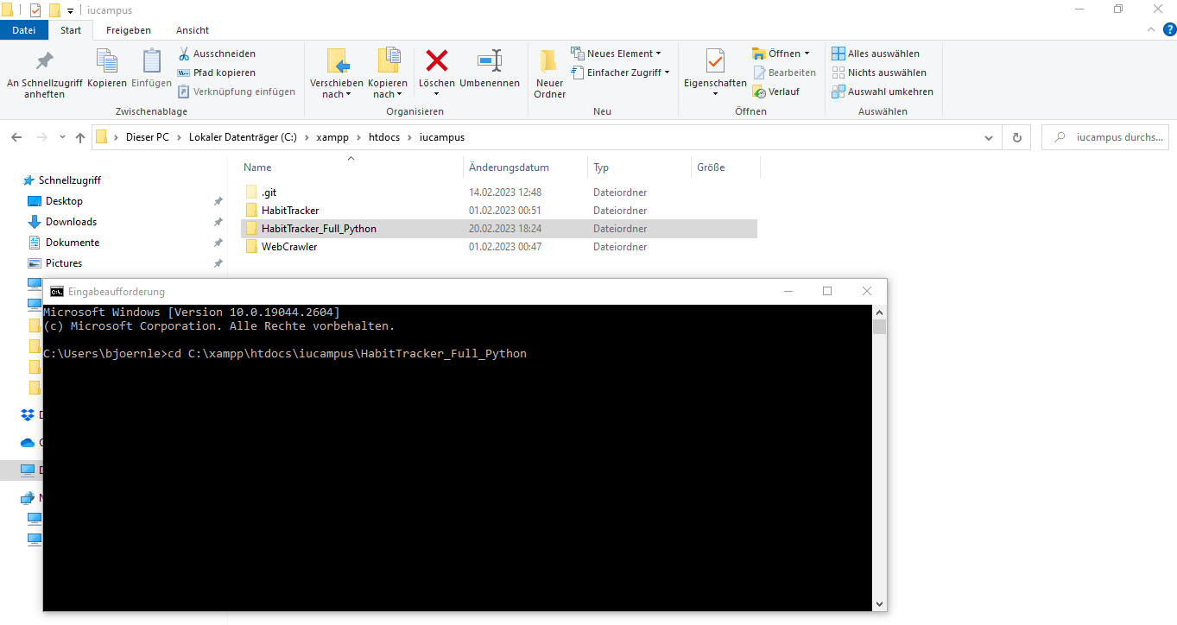

Linux:
First steps:
(Press „Alt“ + „T“ to open a terminal.)
Change to the folder where you placed the app („/usr/USERNAME/HabitTracker“)

Use the app

For example to running an local server, type the following, otherwise look to README.md.
python HabitTracker.py action=StartServer

Starting the app with webinterface

See the „first steps“ for your operating system, seen at „Starting app by commandline“
Then type something like..
python HabitTracker.py action=StartServer
Voila!
Another commandline will be opened, that will serve the app in your local network.
Additionally the standard webbrowser will be opened with the ip where you find the app.
That means, now you're able to use the app without typing so much and with better input control in your whole home-network, if you're connected to your router.
Login to the app
For first tests you could use the credentials
Username: admin
Password: pwd
But you're able to add a user by commandline, after that you could login with that profile.
python HabitTracker.py action=SignupUser username=USERNAME password=PASSWORD

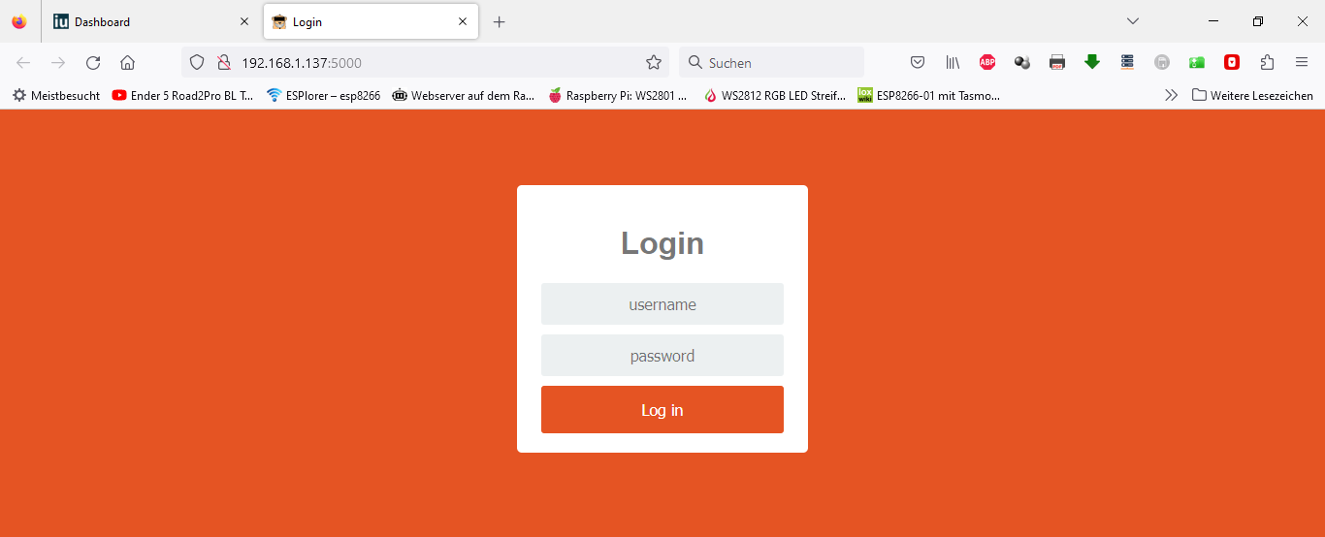
Web userinterface
Login

Startpage
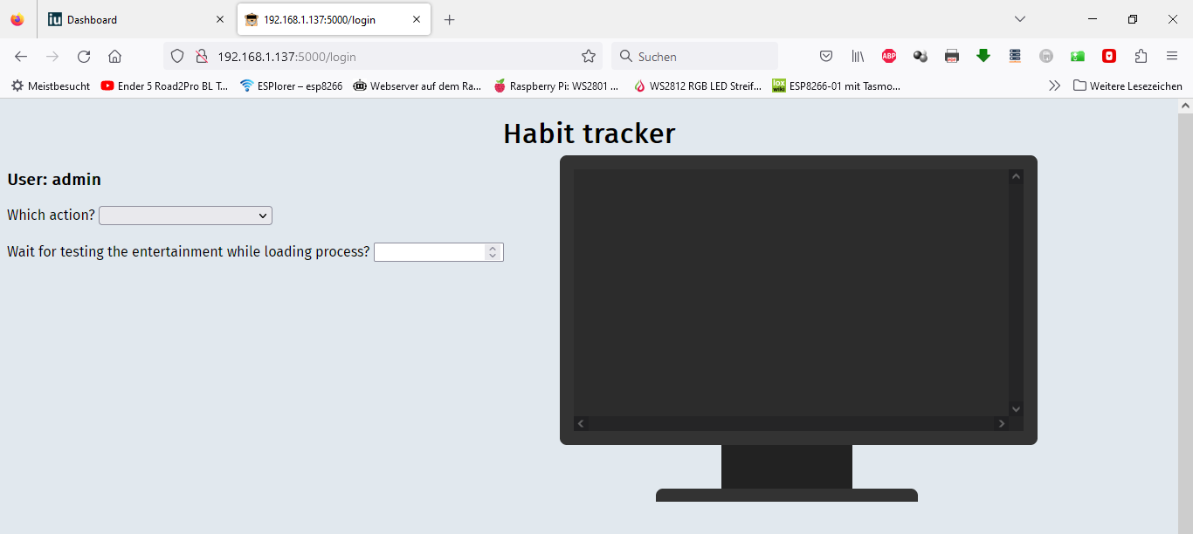
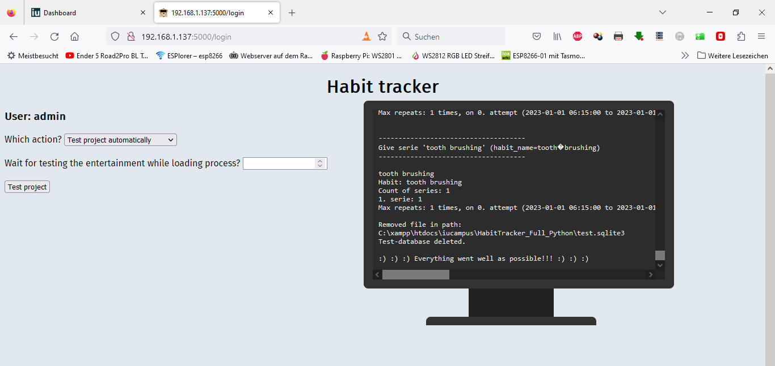
Done request

To-Do's

Take all to universal text translation (a proplem that was shown by the unknown char (?) in the monitor. It's the UTF8 char for the hyper 3 instead of the space char.
(just to replace (for fast troubleshooting), but for universal translating not the end of the line)
Create a class for user roles and authorization for functions.
Complete the userinterface with implementation of that auth class.
Create a better template for using the app. (I created the possibillity that the python functions return json instead text, for HTML views)
…
and become version 1.0...
…
Create some gaming inspirations like points and benefits.
…
and become version 2.0...

